Security and Monitoring
Security Services
- Cloud IAM
- Security Command Center
- Cloud Armor
- Secret Manager
Monitoring Services
Cloud Operations Suite
- Cloud Monitoring
- Cloud Logging
- Error Reporting
- Trace
Data Engineering Services
BigQuery
- Data Warehousing
- Query Processing
- Cost Optimization
Dataflow
ETL Processing
- Batch Processing
- Streaming Processing
Pub/Sub
Messaging Service
- Publishers
- Subscribers
Dataproc
Managed Hadoop & Spark

Security and Monitoring
These are essential components of GCP. They help organizations protect cloud resources, control access, identify security threats, monitor application performance, & troubleshoot issues.
Security Services
- Cloud IAM
Cloud IAM is a security service used to manage who can access Google Cloud resources & what actions they can perform.
Key Concepts of Cloud IAM
  - Principals
  - Roles
  - Permissions
  - IAM Policies
  - Least Privilege
- Security Command Center
Security Command Center is Google Cloud’s centralized security & risk management platform.
Key Features of Security Command Center
  - Security Posture Management – Evaluates the security configuration of cloud resources.
  - Threat Detection – Identifies suspicious activities & potential security threats.
  - Vulnerability Detection – Helps identify security weaknesses & misconfiguration.
  - Security Findings – Provides information about detected security risks.
  - Compliance Monitoring – Helps organizations evaluate compliance with security standards.
- Cloud Armor
Cloud Armor is a network security service designed to protect applications against malicious internet traffic & attacks.
Key Features of Cloud Armor
  - DDoS Protection – Helps defend applications against the DDoS attacks.
  - Web Application Firewall (WAF) – Protects against common web attacks, including SQL injection & cross-site scripting.
  - IP-Based Access Control – Allows or blocks traffic based on IP addresses.
  - Rate Limiting: Controls excessive requests from clients.
  - Security Policies – Defines rules for filtering incoming application traffic.
- Secret Manager
Secret Manager is a secure service for storing & managing sensitive application information.
Key Features of Secret Manager
  - Secret Storage – Securely stores password, API Keys, tokens, & credentials.
  - Encryption – Protects secrets using encryption.
  - Access Control – Uses IAM to restrict access to sensitive information.
  - Secrets Versioning – Maintains multiple versions of stored secrets.
  - Audit Logging – Supports tracking access & administrative activities through Cloud Audit Logs.
Monitoring Services in GCP
Google Cloud Operations Suite
The Google Cloud Operations Suite, also known as Google Cloud Observability, provides tools to monitor, analyse, & troubleshoot cloud applications & infrastructure.
Primary Objectives
- Monitoring infrastructure health & application performance.
- Collect & analyse operational information.
- Identify application errors.
- Detect performance bottlenecks.
- Improve application reliability & availability.
Major Services
- Cloud Monitoring
Cloud Monitoring collects & analyses metrics related to cloud infrastructure & application performance.
Key Features of Cloud Monitoring
  - Metrics Collection
  - Dashboards
  - Alerting Policies
  - Uptime Check
  - Performance Analysis
- Cloud Logging
Cloud Logging is centralized service for collecting, storing, searching, & analysing logs generated by cloud resources & applications.
Key Features of Cloud Logging
  - Log Collections
  - Centralized Log Management
  - Log Explorer
  - Log-Based Metrics
  - Log Retention
- Error Reporting
Error Reporting helps identify, group, & analyse application errors.
Key Features of Error Reporting
  - Error Detection
  - Error Grouping
  - Error Tracking
  - Error Notifications
  - Error Analysis
- Cloud Trace
Cloud Trace is distributed tracing service used to analyse application latency & request performance.
Key Features of Cloud Trace
  - Distributing Tracing
  - Latency Analysis
  - Performance Bottleneck Detection
  - Trace Visualization
  - Performance Optimization
Security & Monitoring Services Together
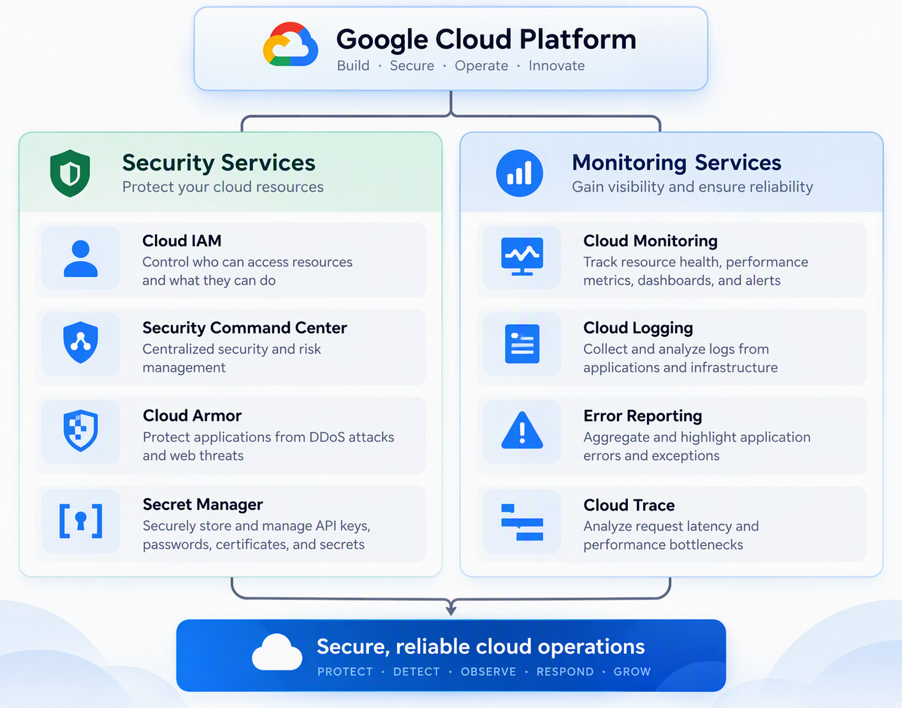
Data Engineering Services
Data Engineering in GCP involves collecting, storing, processing, transforming, & analysing large volumes of data using managed cloud services.
GCP provide scalable services that help organizations build data pipelines, process real-time data, & perform analytics without managing complex infrastructures.
BigQuery
BigQuery is a fully managed, serverless data warehouse designed to store & analyse large datasets using SQL.
Important Concepts
- Data Warehousing
A data warehouse is a centralized system used to store structured/semi-structured data for reporting & analysis.
- Query Processing
BigQuery uses a distributed query processing architecture to execute analytical SQL queries.
- Cost Optimization
BigQuery provides mechanisms to control data storage & query processing costs.
Dataflow
Dataflow is a fully managed data processing service used to develop & execute large-scale data pipelines. It supports both batch & streaming data processing using Apache Beam programming model.
ETL Processing
- Batch Processing
- Streaming Processing
Pub/Sub
Google Cloud Pub/Sub is a fully managed, asynchronous messaging service used for communication between applications & services.
Messaging Service
- Publishers
- Subscribers
Dataproc
Dataproc is a managed GCP service designed to run Apache Spark, Apache Hadoop, & related open-source big data processing technologies.

Comparison of GCP Data Engineering Services
Feature | BigQuery | Dataflow | Pub/Sub | Dataproc
Primary role | Analytics | Data processing | Messaging | Big data processing
Serverless option | Yes | Yes | Yes | Yes, for Spark
Batch processing | Yes | Yes | Not a processing engine | Yes
Streaming | Streaming ingestion and analytics | Yes | Message ingestion and delivery | Spark streaming
SQL support | Native | Through supported pipelines | No | Spark SQL
Infrastructure management | Minimal | Minimal | Minimal | Managed clusters or serverless

